Residential Painting Weekend – Friday, 12th to Sunday, 14th April 2024

at Lily Pad Cottages, Northfield Lane, Nassington, PE8 6QJ

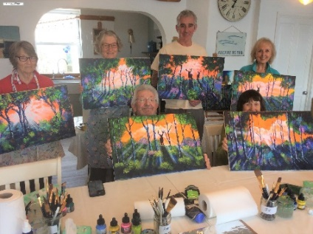 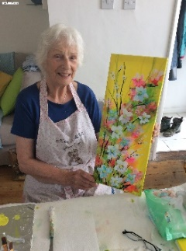 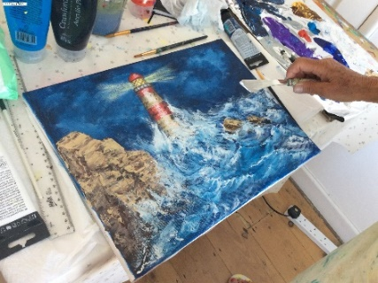

Sophia absolutely loves to paint and nothing gives her greater joy than

passing on this ability to others.

**Learn to paint….. yes, you can!**

**It is possible and no painting experience is required.**

This also includes those wishing to improve their painting skills & discover new and exciting tips.

**Painting weekends are inclusive of all materials (even aprons), morning/afternoon tea break and a delicious home-made lunch so nothing to bring but the wish to try something new.**

Classes are kept to a maximum of twelve to ensure individual attention and a relaxed atmosphere.

​

​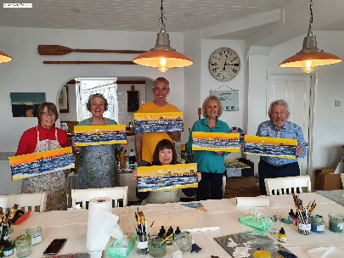

What's included in your break:-

|  |  |  |
| --- | --- | --- |
| Acrylic Art Classes​  ​  70% of art students who have lessons with Sophia have never painted.  Sophia goes through each painting step-by-step, leaving plenty of space for you to develop your own ideas.  Sophia also teaches those who have more experience and wish to develop their skills.  The tuition is fun, informal and supportive. Although we travel through the process one step at a time, there is the opportunity to paint whatever one wishes. It is simply a starting point for people to develop their own style and come up with alternative ideas. | Lunch  ​  When you stop for lunch at 12:30 you'll be treated to delicious home-made soup/bread followed by cake.  ​  Tea and Coffee breaks will also be included  Accommodation  ​  Lily Pad Cottages in Nassington is known for its lovely location and relaxing space.  ​  Self-Catering cottages and apartments provide a comfortable stay with a heated indoor swimming pool on site surrounded by local walks. | |
| Itinerary  ​  Check in 4pm on Friday 12th and depart approx. 12.30pm on Sunday 14th.  ​  Our package rate is £435 and includes:  ​  One & a Half Days of Acrylic Art Classes​.  **Friday:** Welcome drinks/canapes followed by an introduction from Sophia  **Saturday**: 9.30am start, with a break in morning and afternoon, we have  lunch at 12:30 for an hour and  finish the day at approx. 3.30/4pm.  ​  Home-made lunch, tea/coffee breaks  **Sunday:** Bacon Roll provided!  9.30am start with a mid-morning break, finishing at 12.30pm  Tea/coffee break inclusive of cake  **Evenings:** 6pm bookings will be made at a local nearby public house to ensure we have a variety of delicious food and menus (optional). This is not included leaving you free to make your own choice.  2 nights self-catering cottage/apartment | |  | |

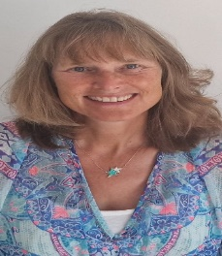

I have been a professional artist and art tutor for many years.

I teach regularly both in the UK and overseas at times too, running Residential Painting Holidays, giving demonstrations and holding art exhibitions.  In addition, I arrange Isle of Wight Painting Breaks together with local and online classes.  I was particularly happy when one of my original paintings was used as the front cover of an inspirational book by an Australian Author.

​

I believe true art is about letting go and it’s this I wish you to experience – there are no mistakes only discovery and learning.  I believe everyone can paint; you just need to be shown in a way that is right for you.  My aim is to build up your confidence, leaving you, the space to relax and have fun.

​

I particularly love to teach people of all abilities/ages, especially those who have never painted before. Classes are fun and enjoyable – you’ll be painting before you know it.

www.sophiaflowers.com